Name ____________________________________________________________________period ________

Watch the required PowerPoint for information you will need to complete this worksheet.

Step 1 - Complete the credit line for the work.
 | Credit line (20 pts)
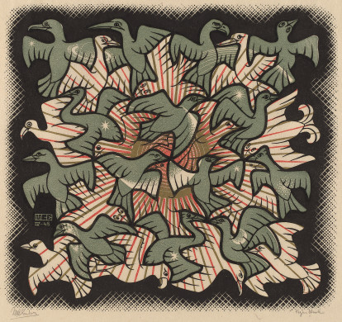 | Artist:
 | Nationality:
 | Title:
 | Date:
 | Medium:
 | Size:

Type the questions in the PowerPoint in Steps 2-5 and then type your answers using complete sentences.
(the boxes will expand as you type)
Remember you must give specific details that supports each of your answers while using correct art terminology.
Step 2 (20 points) DESCRIBE QUESTION-

Step 3 (20 points) ANALYZE QUESTION-

Step 4 (20 points) INTERPRET QUESTION -

Step 5 (20 points) JUDGE QUESTION -

