Name : period ________ /#________

Step 1 -
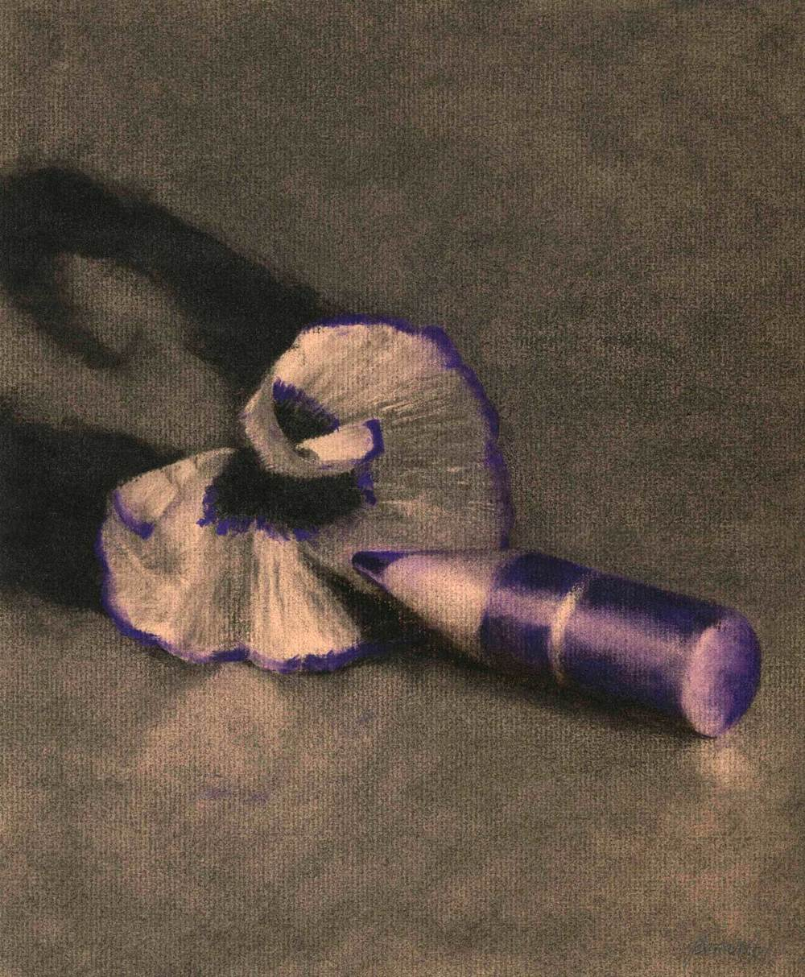 | Credit line (20 pts)
 | Artist:
 | Nationality:
 | Title:
 | Date:
 | Medium:
 | Size:
 | Location: Not given
WRITE the questions from the Jo Brandney PowerPoint in Steps 2-5 and then write your answers using complete sentences.
Remember you must give specific details that supports each of your answers while using correct art terminology.
Step 2 (20 points) DESCRIBE QUESTION- What do you see in the foreground, middle ground, and background
in this drawing?

Step 3 (20 points) ANALYZE QUESTION- What type two types of textures do you see in this drawing?

Step 4 (20 points) INTERPRET QUESTION – What was the artist saying with a short pencil sub and shaving?

Step 5 (20 points) JUDGE QUESTION – How well did the artist show shadows in this drawing?

