Name __TYPE in your NAME!_________________________________period ________
When finish save as lastnamefirstinitial_cutlayers_period.pdf Then upload your pfd file into Focus for grading. You will have 10 points taken off for not saving and uploading your work the correct way!

Part 1. Fill in the information required for each work of art in the “Cut Layers Warmup” PowerPoint.

 | Credit line (10pts)
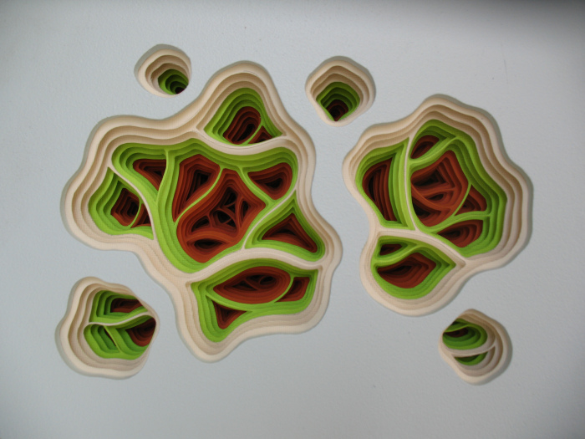 | Artist:
 | Nationality:
 | Title:
 | Date:
 | Medium:
 | Size:

Credit line (10 pts)
Artist:
Nationality:
Title:
Date:
Medium:

Size:

Part 2. Art Criticism (Feldman’s approach)
Type the questions from the PowerPoint for each question and then type a paragraph for each answer (3-4 complete sentences) Remember you must give specific details that supports each of your answers while using correct art terminology. Each question is worth 20 points

DESCRIBE question -

Answer –

ANALYZE question –

Answer

INTERPRET question -

Answer –

JUDGE question -

Answer –

